

CA1 - Statistical Techniques for Data Analysis
Student Full Name
Jessica Helena Ribeiro
Student Number
2026617
Module Title
Statistical Techniques for Data Analysis
Assessment Title
CA1
Lecturer/Supervisor
Taufique Ahmed
Assessment Due Date
01/11/2026
Date of Submission
31/10/2026
Use of AI Tools
I acknowledge the use of Chat GPT for the purpose of helping me better understand the Python codes I learned in class and compare them with those that could be used in my work. I used AI to correct my code, suggest additional functions and commands that could help me develop my work further, and explain every line of code I was using, so I could better understand its purpose and how to apply it effectively to my project.
Contents

- Introduction
- Dataset Description and Descriptive Statistics
2.1 Dataset Overview
2.2 Data Preparation
2.3 Descriptive Statistical Analysis
2.4 Visual Analysis
- Discrete Probability Distributions
3.1 Binomial Distribution
3.2 Poisson Distribution
3.3 Comparison and Interpretation
- Normal Distribution
- Discussion and Conclusion
- References
- Appendix A – Use of Artificial Intelligence
- Appendix B – Reflection on Learning

1. Introduction
This report uses Python to analyse the Bank Marketing dataset. It looks at custumer details and campaign factor that may be linked if a costumer subscribes to a term deposit. The work include descriptive statistics, graphs, Binomial, Poisson and Normal distribution. The main question for this is@: Which customer and campaign details are linked to campaign success? The analyses can show patterns, but it cannot prove that one facor causes a customer to subscribe.
2. Dataset Description and Descriptive Statistics
The Bank Marketing dataset contains 45,211 customer records and 17 columns where includes details such as age, job, marital status and education, as well as account balance and campign contact information. The column Y shows if a customer subscribed to a term deposit (yes or no). Jupyter notebook showed 7 interger columns and 10 text columns.
2.1 Data Preparation
The file was imported using pandas read_csv(). I used sep=’;’ because the values were separated by semicolons, not commas. Used info() to check data type and isnull().sum() to check for empty values. No standard missing values were found, but some entries are recorded as “unknown”: 288 in job, 1857 in education, 13020 in contact and 36959 in poutcome. It was kept the values because if removed or changed without reason could affect the results. It was also examined the numerical variables using the mean, median, standard deviation, variance and skewness.
2.2 Descriptive Statistical Analysis
Descriptive statistics were calculated for five numerical variables: age, balance, duration, campaign and previous. The mean age was 40.94 years and the median was 39 years. Balance had a mean of 1,362.27 and a median of 448. The difference suggests that some high balances increase the average. Balances ranged from -8,019 to 102,127, shows a wide spread.
The mean call duration was 258.16 secods and the median was 180 secods, given the idea that some calls increase the average. The mean number of contacts in the current campaign was 2.76, with a median of 2. For previous contact, the mean was 0.58 and the median was zero. At least half of customers had no previous contact recorded. The graph shows these patterns.

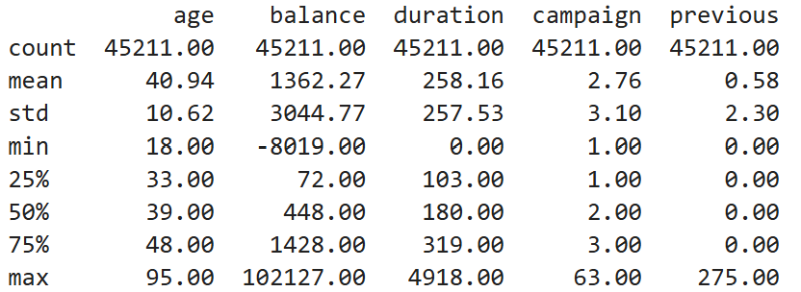

2.3 Visual Analysis
The age variable ranges from 18 to 95 years, with a mean of 40.94 years and a median of 39 years. The highest frequencies occur among customers in their early thirties, with 2,085 customers aged 32 and 1,996 aged 31. The mean being higher than the median, together with a skewness value of 0.685, suggests a moderately right-skewed distribution. This indicates that the distribution is not perfectly symmetrical, although further graphical analysis is required before assessing whether a normal distribution provides a reasonable approximation.
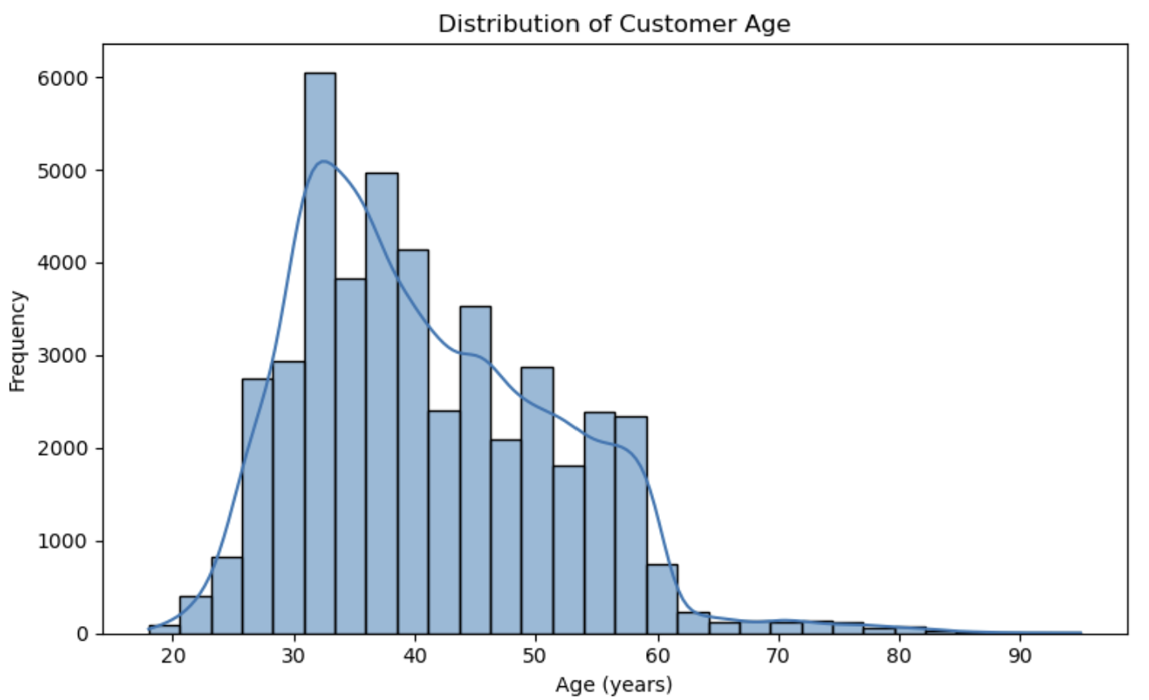
Figure 1. Distribution of Customer Age.
The analysis revealed differences in term deposit subscription rates across occupational categories. Students recorded the highest observed subscription rate at 28.68%, followed by retired customers at 22.79% and unemployed customers at 15.50%. In contrast, blue-collar workers had the lowest rate at 7.27%, followed by entrepreneurs at 8.27% and housemaids at 8.79%. The student subscription rate was almost four times the rate observed among blue-collar workers. These differences may be useful when investigating customer segments, but they do not establish that occupation causes campaign success. The number of customers in each occupational category should also be considered when interpreting the results.

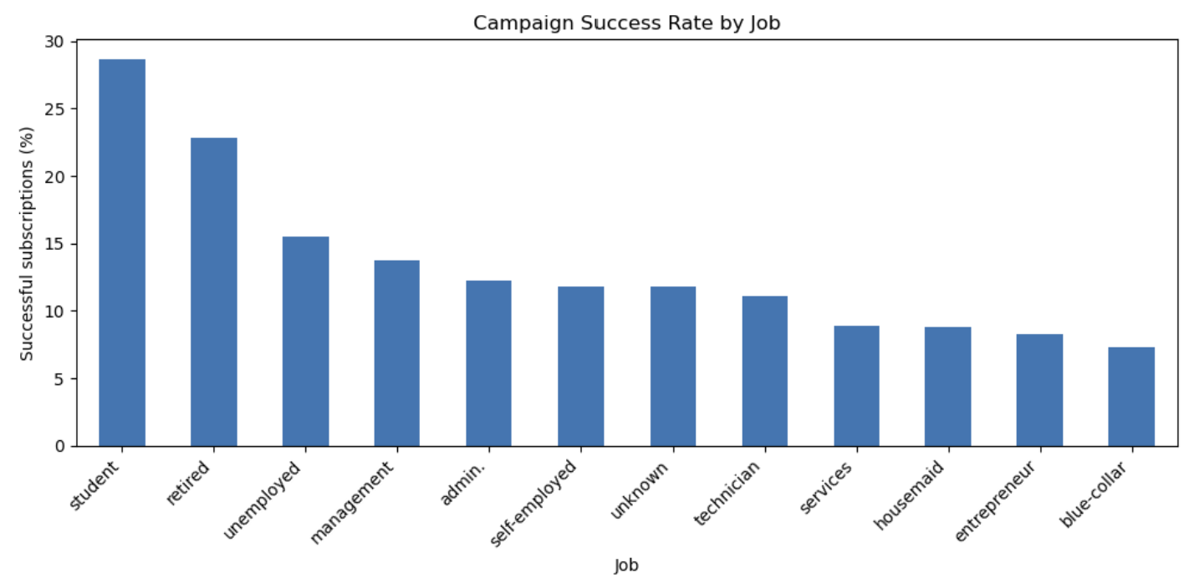
Figure 2. Campaign Success Rate by Job
The analysis compared customers account balances according to whether they subscribed to a term deposit. Customers who subscribed had a higher mean balance of 1,804.27, compared with 1,303.71 among customers who did not subscribe. The median balances were also higher for subscribers (733) than for non-subscribers (417). In both groups, the mean was substantially higher than the median, suggesting positively skewed distributions influenced by customers with relatively large balances. The high standard deviations indicate considerable variation in account balances within both groups. Although these results suggest an association between account balance and campaign outcome, they do not establish a causal relationship.

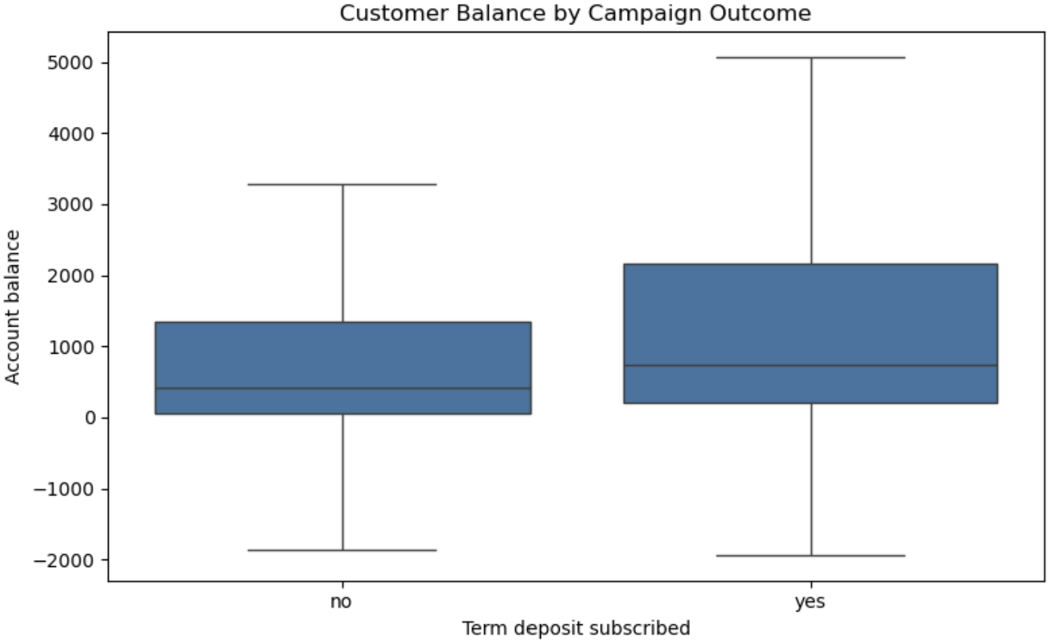
Figure 3. Customer Balance by Campaign Outcome
3. Discrete Probability Distributions
3.1 Binomial Distribution
The Binomial distribution was used to estimate the probability of a specific number of successful term deposit subscriptions among a group of customers. The observed subscription rate in the dataset was approximately 11.70%. Assuming that each customer has the same probability of subscribing and that customer outcomes are independent, the probability of exactly five subscriptions among 30 customers was calculated as 13.92%. This demonstrates how the Binomial distribution can support the estimation of campaign outcomes. However, the assumptions of constant probability and independence may not fully reflect real-world customer behaviour.
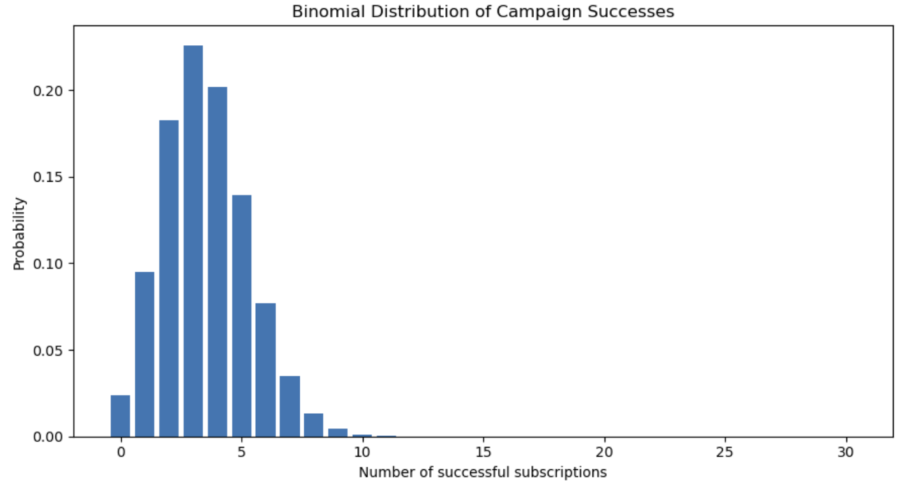
Insert Figure 4 – Binomial Probability Distribution
3.2 Poisson Distribution
The Poisson distribution was considered for modelling the number of previous contacts recorded for each customer. The sample mean was 0.5803, whereas the sample variance was 5.3058. In a Poisson distribution, the theoretical mean and variance are equal. The substantial difference between these values suggests overdispersion and indicates that a simple Poisson model may not adequately represent the observed data. This highlights the importance of comparing the assumptions of a theoretical distribution with the characteristics of the actual dataset before using it for probability estimation.
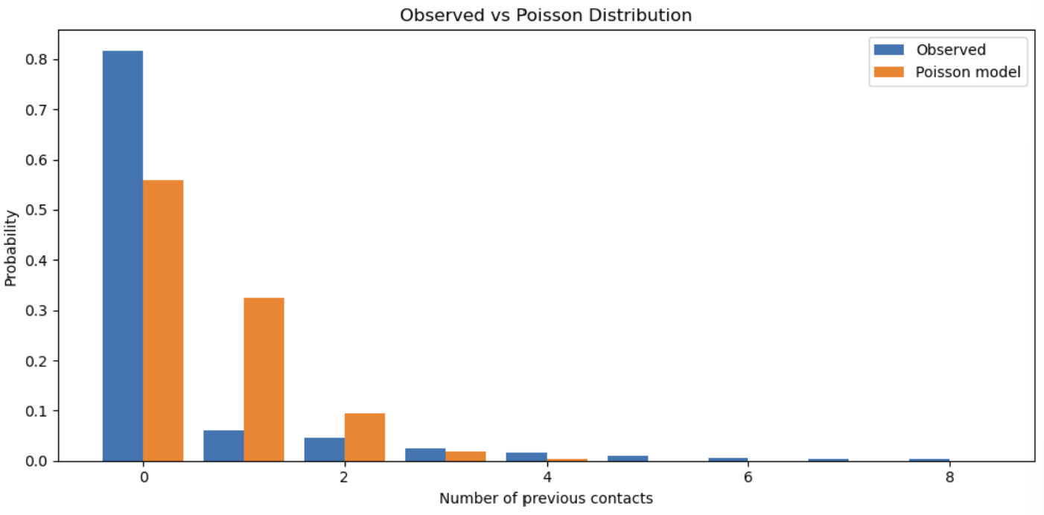

Insert Figure 5 – Observed and Expected Poisson Distributions
3.3 Comparison and Justification of Statistical Distributions
The three probability distributions were investigated for different analytical purposes. The Binomial distribution was used to estimate the probability of a specified number of term deposit subscriptions among a fixed number of customers. With an estimated subscription probability of 11.70%, the probability of exactly five subscriptions among 30 customers was calculated as 13.92%. This model is appropriate when each trial has two possible outcomes, the probability of success remains constant, and the trials are independent. However, these assumptions may not fully reflect customer behaviour in a real marketing campaign.
The Poisson distribution was examined using the number of previous contacts per customer. The observed mean was 0.5803, while the variance was 5.3058. Since a Poisson distribution assumes that its theoretical mean and variance are equal, this substantial difference suggests overdispersion. Consequently, the simple Poisson model may not provide an adequate representation of the observed contact counts. Alternative count models could be investigated in further analysis.
The Normal distribution was assessed using customer age. The mean age was 40.94 years, the standard deviation was 10.62 years, and the skewness coefficient was 0.685. The Q-Q plot showed deviations from the reference line, particularly towards the tails. These findings suggest that the age distribution is not perfectly Normal, although the Normal curve remains useful as a visual reference.
Discrete variables can sometimes be approximated by a Normal distribution under suitable conditions. For a Binomial distribution, a Normal approximation may be reasonable when both the expected number of successes and failures are sufficiently large. For a Poisson distribution, a Normal approximation generally becomes more appropriate when its rate parameter is large. However, the number of observations in a dataset alone does not guarantee a good approximation. The underlying distribution and its parameters must also be considered. In this study, the low mean and substantial overdispersion of the previous-contact variable do not support assuming that a Normal approximation to a simple Poisson model would be satisfactory.
Overall, the analysis demonstrates that statistical distributions should be selected according to the type of variable, the research question, and the extent to which the model assumptions agree with the observed data.
4. Normal Distribution
The Normal distribution was investigated using the customers’ age variable. The mean age was 40.94 years, with a standard deviation of 10.62 years. The skewness coefficient was 0.685, indicating a moderately positively skewed distribution. Since a theoretical Normal distribution is symmetric, this result suggests that the age data do not follow a perfectly Normal distribution. Nevertheless, a fitted Normal curve can provide a useful visual comparison with the observed data. The suitability of this approximation should be assessed by examining the histogram and a Normal Q-Q plot, rather than relying on the mean and standard deviation alone.
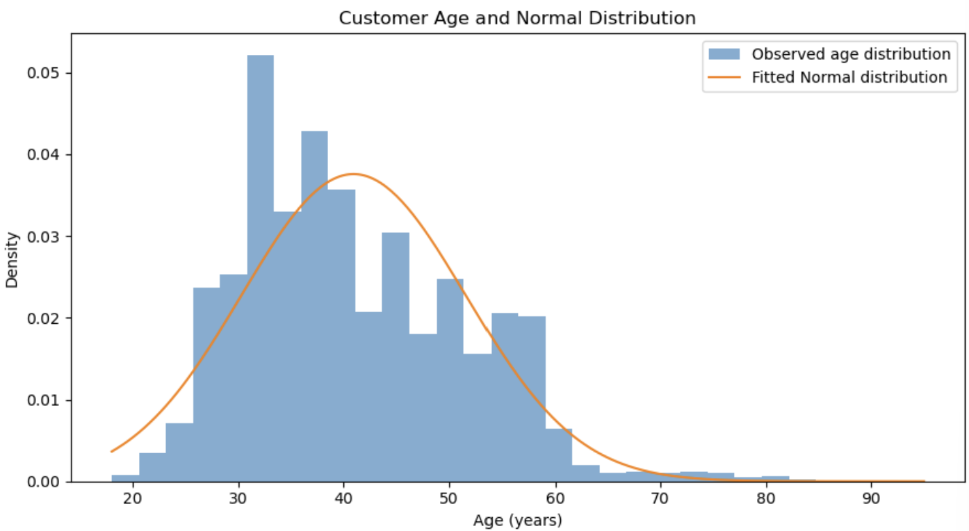
Insert Figure 6 – Observed Distribution and Fitted Normal Curve
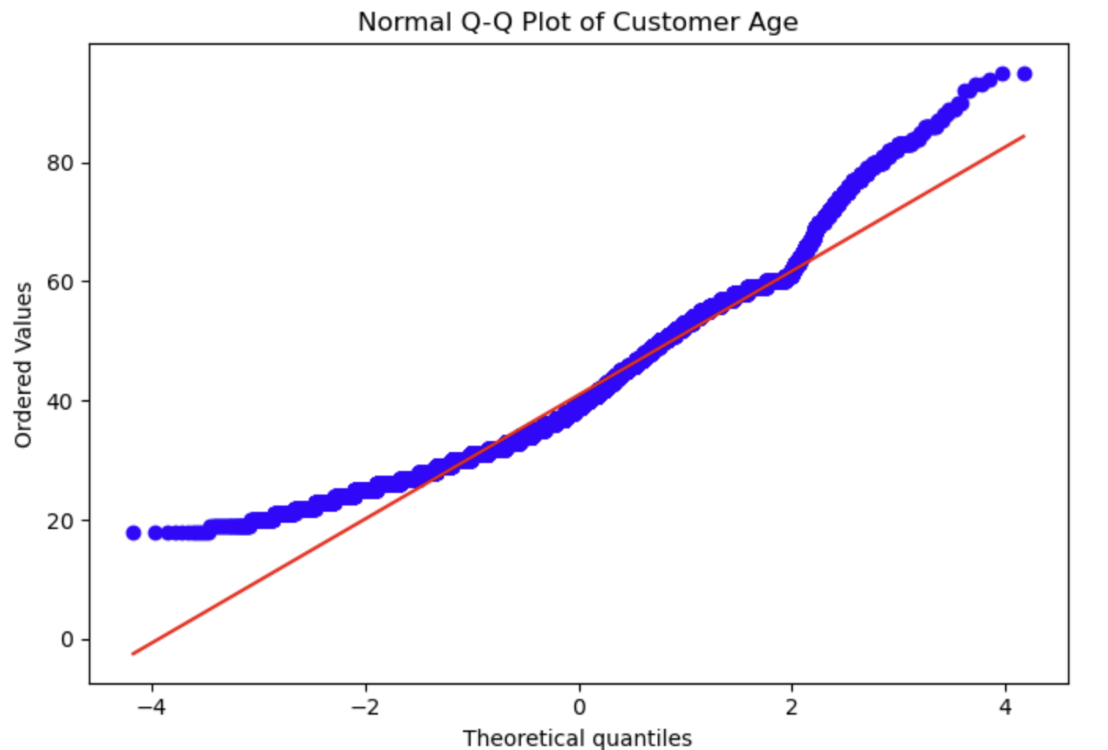
Insert Figure 7 – Normal Q–Q Plot
The Normal Q-Q plot provides further evidence that customer ages do not follow a perfectly Normal distribution. Although many points in the central region lie relatively close to the reference line, noticeable deviations occur towards both tails, particularly among older customers. Combined with the positive skewness coefficient of 0.685, this suggests that the Normal distribution provides only an approximate representation of customer ages. Therefore, the fitted Normal curve should be interpreted cautiously rather than assumed to describe the data accurately.
5. Discussion and Conclusion
This project applied descriptive statistics and probability distributions to the Bank Marketing dataset, which contains 45,211 customer records and 17 variables. The descriptive analysis identified differences in customer characteristics and campaign outcomes. For example, the observed subscription rate was higher among students and retired customers than among several other occupational groups. Customers who subscribed also had a higher mean and median account balance than those who did not subscribe.
The probability analysis demonstrated how the Binomial distribution can estimate the likelihood of a specific number of subscriptions. The Poisson analysis identified a substantial difference between the mean and variance of previous contacts, suggesting that a simple Poisson model may not adequately describe this variable. The Normal distribution analysis also showed deviations from theoretical Normality in customer ages.
Overall, the project demonstrated the value of Python for statistical analysis, data visualisation and probability estimation. It also highlighted the importance of checking model assumptions before drawing conclusions from statistical results.

6. References
[Liste todas as fontes citadas no texto, utilizando o estilo Harvard exigido pelo curso.]
Suggested source to verify and reference:
UCI Machine Learning Repository. Bank Marketing. Available at: https://archive.ics.uci.edu/dataset/222/bank+marketing (Accessed: [date accessed]).
[Acrescente outras fontes académicas ou técnicas efetivamente consultadas, incluindo as utilizadas para explicar os métodos estatísticos. Verifique as regras de Harvard fornecidas pelo CCT.]
7. Appendix A – Use of Artificial Intelligence
[Apêndice obrigatório conforme o enunciado.]
Document your use of AI tools according to the assignment requirements.
Include:
- The AI tool used.
- The exact prompts submitted.
- The corresponding outputs required by the brief.
- How the assistance was used in preparing the assignment.
- What you independently checked, changed or verified.
[Não invente prompts ou outputs. Registe as interações reais e siga exatamente as instruções do enunciado.]
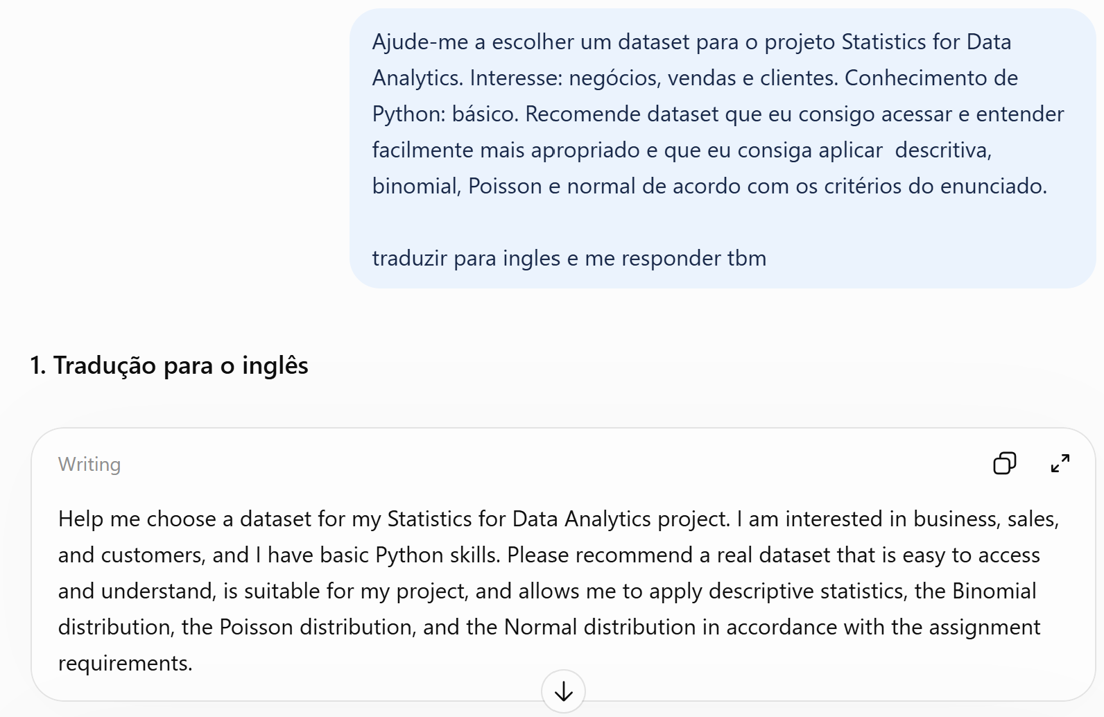
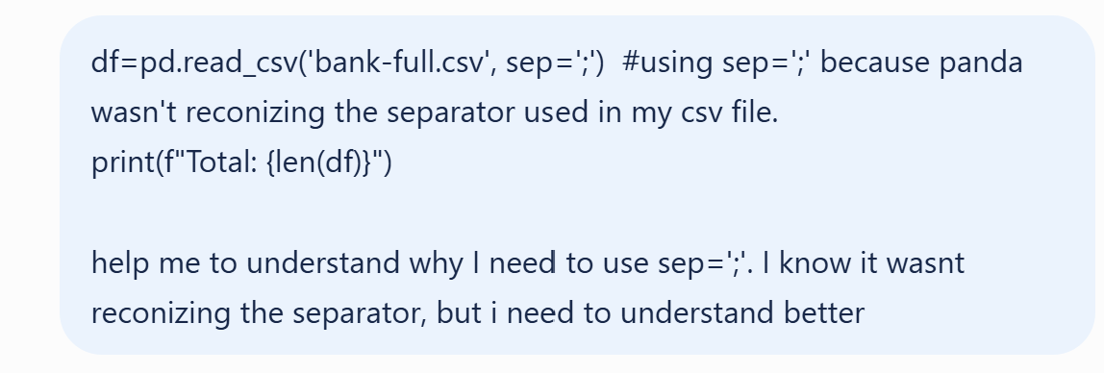
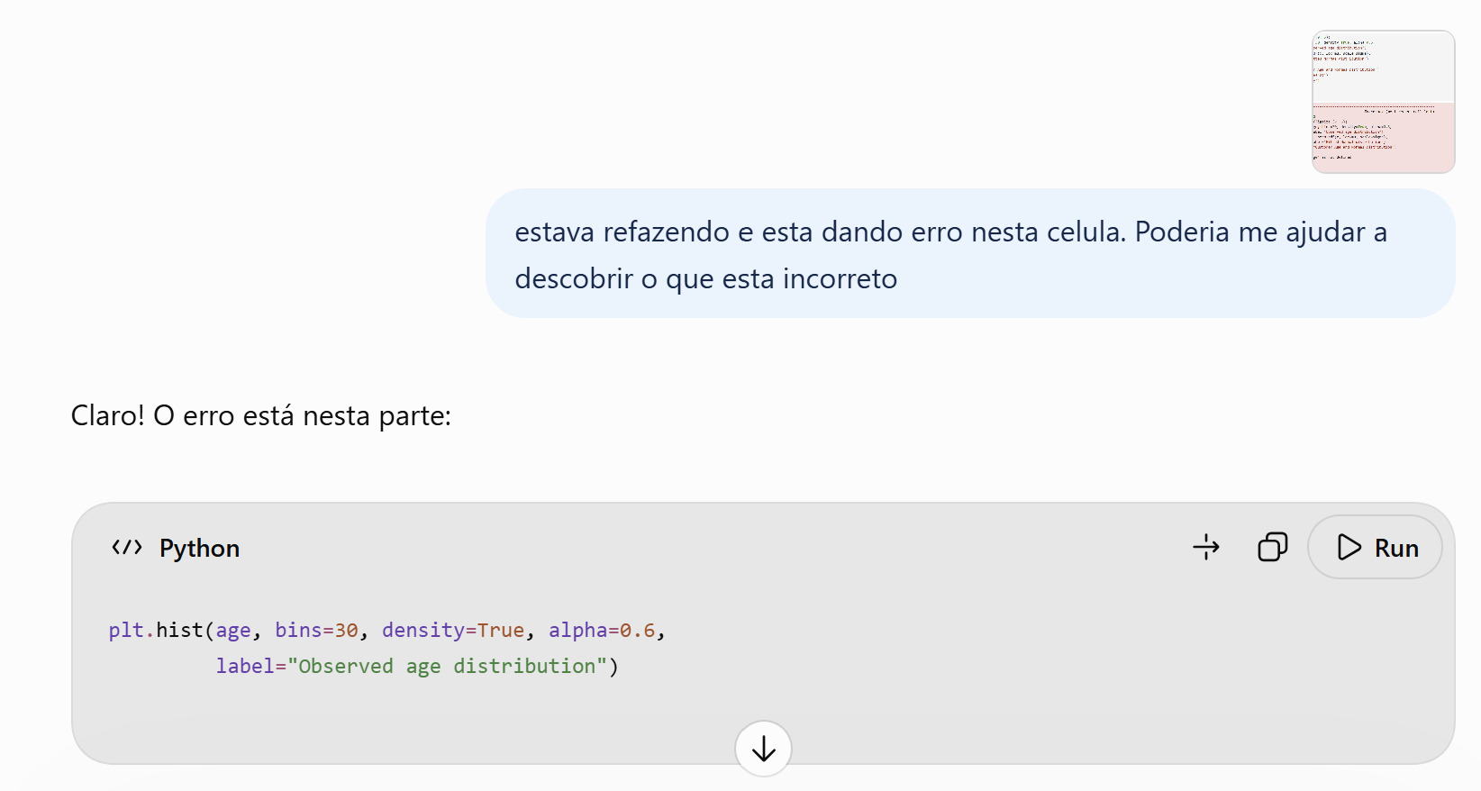
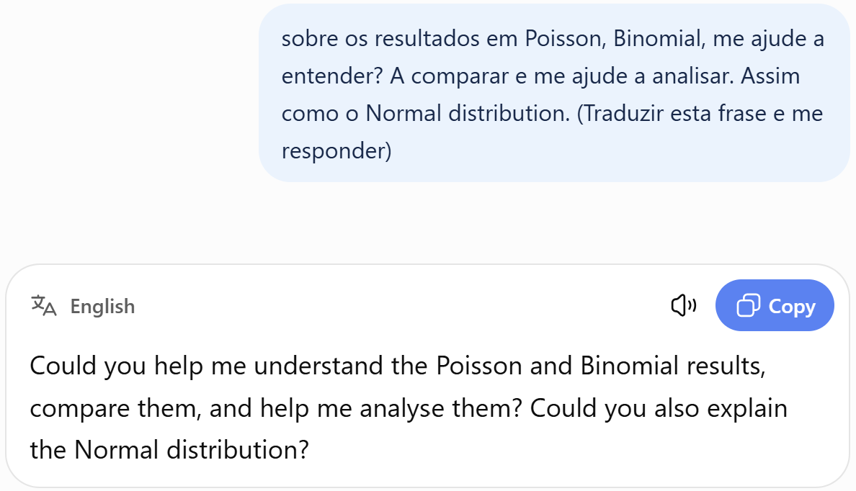
8. Appendix B – Reflection on Learning

